[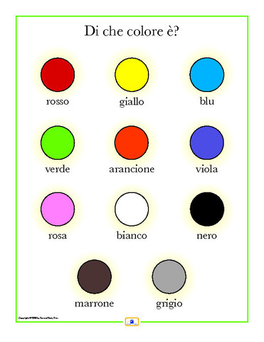](http://www.google.com/url?sa=i&rct=j&q=&esrc=s&frm=1&source=images&cd=&cad=rja&docid=nM3jH1VeVkN9zM&tbnid=Fyr2Dk79b8XBHM:&ved=0CAUQjRw&url=http://www.secondstorypress.com/collections/italiano&ei=HMipUuOaBZe-sQT9kYLQCw&bvm=bv.57967247,d.cWc&psig=AFQjCNEKeK-A7Br5FA7dtMj6f119QAT0KA&ust=1386944808067628)