**Summer Opportunities for Students**

___________________________________________________________________________

**Math programs for high school students**



[All Girls/All Math](http://www.math.unl.edu/pi/outreach/agam)

[AwesomeMath](http://www.awesomemath.org/)



[California State Summer School for Mathematics and Science](http://www.ucop.edu/cosmos/) (COSMOS)

http://dpt.roslynschools.org/hs/math/images/euclidlabspheresv32.png

[Camp Euclid](http://euclidlab.org/) (online)



[Canada/USA Mathcamp](http://www.mathcamp.org/)

[Center for Mathematics, Science, and Technology](http://www.mathismylife.org/index.html) (CMST)

http://dpt.roslynschools.org/hs/math/images/jhu_cty_logo_003.gif

[Center for Talented Youth](http://www.artofproblemsolving.com/Wiki/index.php/Center_for_Talented_Youth) (CTY)



[Clay Research Academy](http://www.claymath.org/programs/outreach/academy/about.php)



[Education Program for Gifted Youth](http://epgy.stanford.edu/) (EPGY)



[Educational Studies Program (ESP) at MIT](http://www.artofproblemsolving.com/Wiki/index.php?title=Educational_Studies_Program&action=edit&redlink=1)



[Hampshire College Summer Studies in Mathematics](http://www.hcssim.org/) (HCSSiM)

[](http://www.ssp.harvard.edu/)

[Harvard Summer School](http://www.ssp.harvard.edu/) (Secondary School Program)



[IDEA MATH Summer Program](http://ideamath.org/summerprog.htm) (For both Middle and High School)[[Forum](http://www.artofproblemsolving.com/Forum/viewforum.php?f=637)]

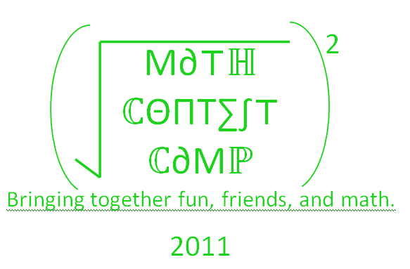

[Math Contest Camp 2011](http://users.sbuniv.edu/~khopkins/2011mcc.html) Grades 5-8 and grades 7-12 in Bolivar, MO



[Math Enrichment Summer Institute at San Jose University](http://www.artofproblemsolving.com/Wiki/index.php?title=Math_Enrichment_Summer_Institute&action=edit&redlink=1)



[Mathematics Institute for Young Scholars at UCLA](http://www.artofproblemsolving.com/Wiki/index.php?title=Mathematics_Institute_for_Young_Scholars&action=edit&redlink=1)

[Mathematics Summer Camp at Texas A&M](http://www.math.tamu.edu/summercamp/)

[Mathematical Olympiad Summer Program](http://amc.maa.org/) hosted by the [AMC](http://amc.maa.org/).

[MathZoom Summer Camp](http://www.mathzoom.com/)

[Michigan Math and Science Scholars](http://www.math.lsa.umich.edu/mmss/)

[Minority Introduction to Engineering and Science](http://web.mit.edu/mites/www/) (MITES)

[MIST Academy](http://www.mistacademy.com/mistsummer.htm) Summer Institute (Birmingham, AL) for students entering grades 4-12

[Program in Mathematics for Young Scientists](http://www.promys.org/) (PROMYS)

Research Science Institute (RSI)

[The Ross Program](http://www.math.ohio-state.edu/ross/)

[Young Scholars Program in Discrete Mathematics](http://dimacs.rutgers.edu/ysp/) at Rutgers

[Stanford University Mathematics Camp](http://math.stanford.edu/sumac/) (SUMP)

[Summer Institute for Mathematics at the University of Washington](http://www.math.washington.edu/~simuw/) (SIMUW)

[Summer Mathematics Institute at Oakland University](http://www.math.oakland.edu/ousmi.html)

[Summer Mathematics Program at University of Utah](http://www.math.utah.edu/hsp/)

[Summer Science Program](http://www.summerscience.org/home/index.php) (SSP) at New Mexico Teach and Happy Valley School.

[Summer Ventures in Science and Mathematics at University of North Carolin](http://www.summerventures.org/)[a](http://www.artofproblemsolving.com/Wiki/index.php?title=University_of_North_Carolina&action=edit&redlink=1)

[SummerMath](http://www.artofproblemsolving.com/Wiki/index.php?title=SummerMath&action=edit&redlink=1) at Mount Holyoke College

[TenMarks Education](http://www.tenmarks.com/) offers summer programs for Grades 9 and 10

[Texas Mathworks Honors Summer Math Camp](http://mathworks.txstate.edu/student/HSMC/description.htm)

[UConn Mentor Connection](http://www.gifted.uconn.edu/mentoruc.html)

[Women's Technology Program at MIT](http://www.artofproblemsolving.com/Wiki/index.php?title=Women's_Technology_Program&action=edit&redlink=1)

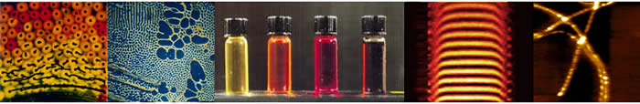

[Young Scholars Program at the University of Chicago](http://www.artofproblemsolving.com/Wiki/index.php?title=Young_Scholars_Program&action=edit&redlink=1)

[](http://www.wpi.edu/Academics/Summer/)

For Students entering their Junior and Senior Year:

[http://www.wpi.edu/+frontier](http://www.wpi.edu/admissions/undergraduate/visit/frontiers.html)

For Students entering their Freshman and Sophomore Year:

[http://www.wpi.edu/+launch](http://www.wpi.edu/admissions/undergraduate/visit/frontiers.html)

___________________________________________________________________________

[](http://www.seas.upenn.edu/)

<http://www.seas.upenn.edu/>

___________________________________________________________________________

[Rutgers Young Scholars Program in Discrete Mathematics](http://dimacs.rutgers.edu/ysp/)

[](http://dimacs.rutgers.edu/ysp/)